“ONE NIGHT

IN

SAN FRANCISCO”


a text adventure about physical security

by

April Seliger, Peter Peterson, Jet Li Braun, and Nick Moffitt

published by Tastytronic Industries

Introduction
Congratulations on buying One Night in San Francisco (ONISF), the newest educational text adventure from Tastytronic Industries! We’re certain that ONISF will give you tens of minutes of fun while also teaching you important principles about physical security as it relates to computer security. By the time you beat ONISF, you’ll have a much better understanding of why physical security is just as, if not more important, than technological security mechanisms, like access control or cryptography.


What is a “Text Adventure?”
The Zork game box (1980). Don’t move in dark spaces or you’ll likely be eaten by a grue.
Text adventures (also known as “interactive fiction” or “story games”) are essentially interactive “choose your own adventure” (CYOA) games. In a CYOA, each page describes a situation and ends in choices; the player makes a choice and turns to the corresponding page to see what happens next. While CYOA books are fun, they are static. It’s not very practical for CYOAs to include interactive creatures, objects, the ability to carry or use items, and so on (you’d need a page for every possible state of the game).

Text adventures, on the other hand, can do all these things and more, because in addition to providing text descriptions and letting the user make choices, the game can simulate other dynamic elements of the game world. You can find a lamp and use it to illuminate dark areas, for example, and you can learn (the hard way) that your lamp will only work for so long before going dead, leaving you in a pitch-black room. You can find and use items, the environment can change over time, objects can move around, and more.

Once upon a time, text adventures were the most immersive and technologically advanced computer games. Graphics in the 1970s and early 1980s were – let’s be honest – not great, and certainly couldn’t hold a candle to your own imagination. By focusing on story, interactivity, and imagination, text adventures could give players a more grand, more engaging, and more immersive experience than “video games.” The ability to type a broad range of natural language instructions and have the game “understand” what you meant was revolutionary.

Video games have come a long way in 50 years – you can now play hi-def 3D virtual reality games in real time with your buddies on the other side of the world. But it’s still going to be a long time before computers and video games can compete with the power of the most massively-parallel computer you own – your brain – and it’s greatest application: your imagination. I mean, there’s a reason people still read books. So, even though text adventures are old-fashioned, we think you’ll enjoy this unique and engaging experience.

How to Play a Text Adventure

In a text adventure, each scene or area is described in written text, and the player types natural language instructions about what to do at a prompt that follows the description. The game understands the objects in the game and a set of common verbs, and tries to do the right thing based on the player’s instructions.

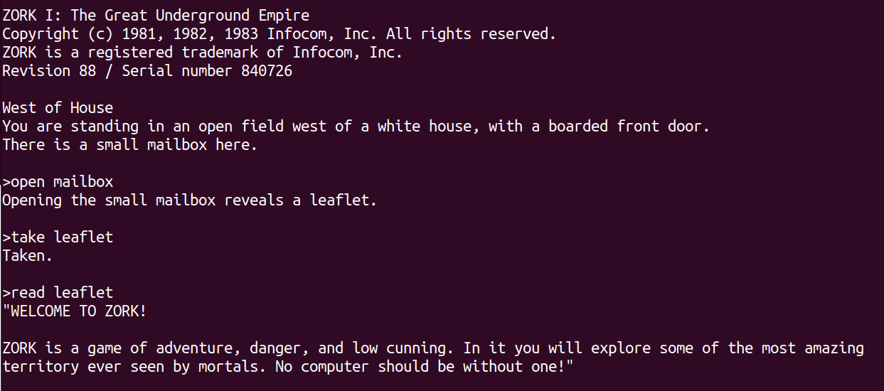
The opening scene of the classic interactive fiction game, Zork.

In addition to nouns and verbs, most text adventures allow you to move from space to space using the names of “exits” (pathways to adjoining areas described in the text) and/or their map direction. Text adventures typically allow the player character to carry and use objects, which are held in the player’s “inventory.” Sometimes you have to find an object in one area and use it in another, or solve puzzles to open new areas to you, and so on.

For example, if you’re in a room and the description says there’s a rusty key on the floor and a doorway to another room to the north, you can type “take key” and the key will be added to your inventory. Then you can type “go north” (or “north” or “n”) and you’ll (probably) walk to the next room, which will then be described.

Suppose in this next room there is a table and on that table is a locked box. You can try something like “unlock box with key”, and if that works, you can try “open box” or “look inside box”. If there’s a cookie in the box, you could “take cookie” and save it for later, or you could just cut to the chase and “eat cookie”. The game would then tell you about the experience – maybe it would say “The cookie was delicious” or, maybe it would say “As you finish the last crumb of the cookie, your body shrinks to the size of an ant!” Who knows.

Text adventure mechanics can take a little getting used to. For example, if you say “cut sandwich with knife” and it says, “Do you mean the nasty knife, or the bejeweled knife?” It may be tempting to respond conversationally, e.g., “The bejeweled one” or “bejeweled” – but the interpreter does not track conversations like that. Simply say “cut sandwich with bejeweled knife”. Sometimes, when you try something, the interpreter will say something like “That wouldn’t be useful” – that could mean that it literally would not be helpful, but it could also mean that the interpreter simply doesn’t understand what you intend from the words that you’re using (and it thinks what you mean is pointless). In any case, it’s best to think of working with the interpreter as something of a puzzle itself. You’re trying to get the interpreter to understand what you mean so that you can figure out if what you are trying to do will work. Try different ways of saying the same thing.

Text adventures usually have some kind of objective, or perhaps simply are a story that can be told in many different ways. Text adventures don’t always tell you what to do or expect, and figuring that out is often part of the fun. The best thing is that you can’t really break anything, so just experiment and see what happens.


Classic Physical Security Issues
A toilet plunger.
Physical security is surprisingly hard to get right, because it requires expertise and financial resources. Security is almost never free; it almost always costs more than insecurity. Vaults, safes, fences, reinforced walls, scanners, locks, etc. – all these things cost money and require that the relevant parties understand how these physical controls can be circumvented.

There are a number of classic ways that physical security can go wrong:

Insufficiently strong walls and doors. A classic approach to a locked door is to go through a wall. Maybe it’s easier to go through an adjoining wall (or floor!). If the front door won’t open, maybe you can make your own door – or simply break the door down. Offices, in particular, are not places that are typically designed for security – drywall and interior office doors are not exactly indestructible.

Locks are not all the same. There are many different kinds of locking mechanisms on doors, and some of them are much easier to circumvent than others. The locking mechanism on many doors can easily be circumvented using a coat hanger or a credit card.

Fancy doesn’t mean secure. Many security mechanisms are not as cool as they look. Sometimes there’s a way to get around the mechanism if you stop focusing on the obvious path.

There’s a right way to hang a door. At least for security there is! Doors typically have hinges, and the hinges typically swing on a pin that holds the two pieces of the hinge together. That means that, if the pins of the hinge are exposed to the insecure world, sometimes you can simply take the door off its hinges if you have a tool that can remove the pins. (Some fancy hinges have permanent pins.)

Insecure spaces. Again, most places in the real world are not built for security, they’re built for comfort, cheapness, or to serve some technical purpose. Many buildings use what are called “suspended ceilings” – rectangular and modular ceiling materials that reduce noise. Light fixtures and the individual panels (sometimes called “acoustic tile”) are set into in a metal framework that is hung (“suspended”) from the actual physical ceiling – often one to two feet above the visible ceiling. Electrical wiring and HVAC ducts are frequently run between the visible suspended ceiling and the actual structural ceiling. And, for convenience and cheapness, walls in the space often only extend up to the suspended ceiling, meaning that you can get from room to room through this ceiling.

This idea can even extend to flooring. Data centers often have what’s called a “raised floor” – this is like a suspended ceiling, only upside down. With a raised floor, a framework of pillars are attached to the structural floor of the building, and heavy-duty square panels of flooring are set on top, again so that electrical and ventilation systems can be made invisible and out of the way.

Check under the doormat. Security and convenience are locked in an eternal struggle. It really stinks to be locked out of a place that you need to be in. So, people often leave spare keys in places that are accessible to those who need access. Frequently the spare keys are in a much-less secure place than the primary key.


Cybersecurity > Physical Security?
A promotional drawing of the IBM 5100 portable computer.
It’s a common misconception that cybersecurity removes the need for physical security. After all, isn’t that what usernames, passwords, and encryption is for? If the adversary lacks the password or encryption key, they won’t be able to get the data on the computer, right?

Not necessarily. There are a few fundamental issues that result in physical security being more important than cybersecurity.

Sometimes people don’t encrypt things. While encryption can protect data “at rest,” people sometimes don’t encrypt things for various reasons. Maybe there’s a technical reason they can’t (e.g., the device can’t do it), maybe it’s inconvenient, or maybe they simply think that their physical security is so strong that they don’t need to bother with encryption. Unfortunately for them, this means that if you can somehow acquire their unencrypted data, you can read it without any problem. A classic example of this is the organization with strong cybersecurity mechanisms, but that keeps unencrypted backups in a less-secure place (e.g., a desk drawer in a regular office).

Usernames and passwords are enforced by the operating system. Usernames and passwords are authentication mechanisms enforced by a running operating system (OS), typically the one that is installed on the hard drive and that boots by default when the power is turned on. That OS can only enforce that authentication process if it is the one that’s currently running. If you can take the hard drive out of a computer and put it into a different computer, or you can boot the computer using an OS on another device (e.g., a USB stick, SD card, or external disk), you can frequently read the hard drive without any restrictions.

Systems relying on a secret are only as good as the secret. User accounts and data are frequently protected by secrets, such as passwords or encryption keys. If the adversary must go through the mechanism (i.e., there’s no “trick” to avoid it), then the security of the system depends on the difficulty of guessing the secret. If the secret is not large and random enough, the adversary might be able to guess it. Sometimes there are clues in the environment that can provide the secret (e.g., a “sticky note” with a password on it). Other times, the adversary can’t guess the password themselves, but if they can take the encrypted data elsewhere, they can use a computer to guess the secret using an “offline brute force” attack – literally trying combinations until something works.

The analog hole. Sometimes there are security mechanisms that make it impossible to copy data to a device (like a USB stick), but an adversary can still copy the important data by hand or some other way, such as by printing it or taking pictures of it. If the data can be displayed, it can be exfiltrated.

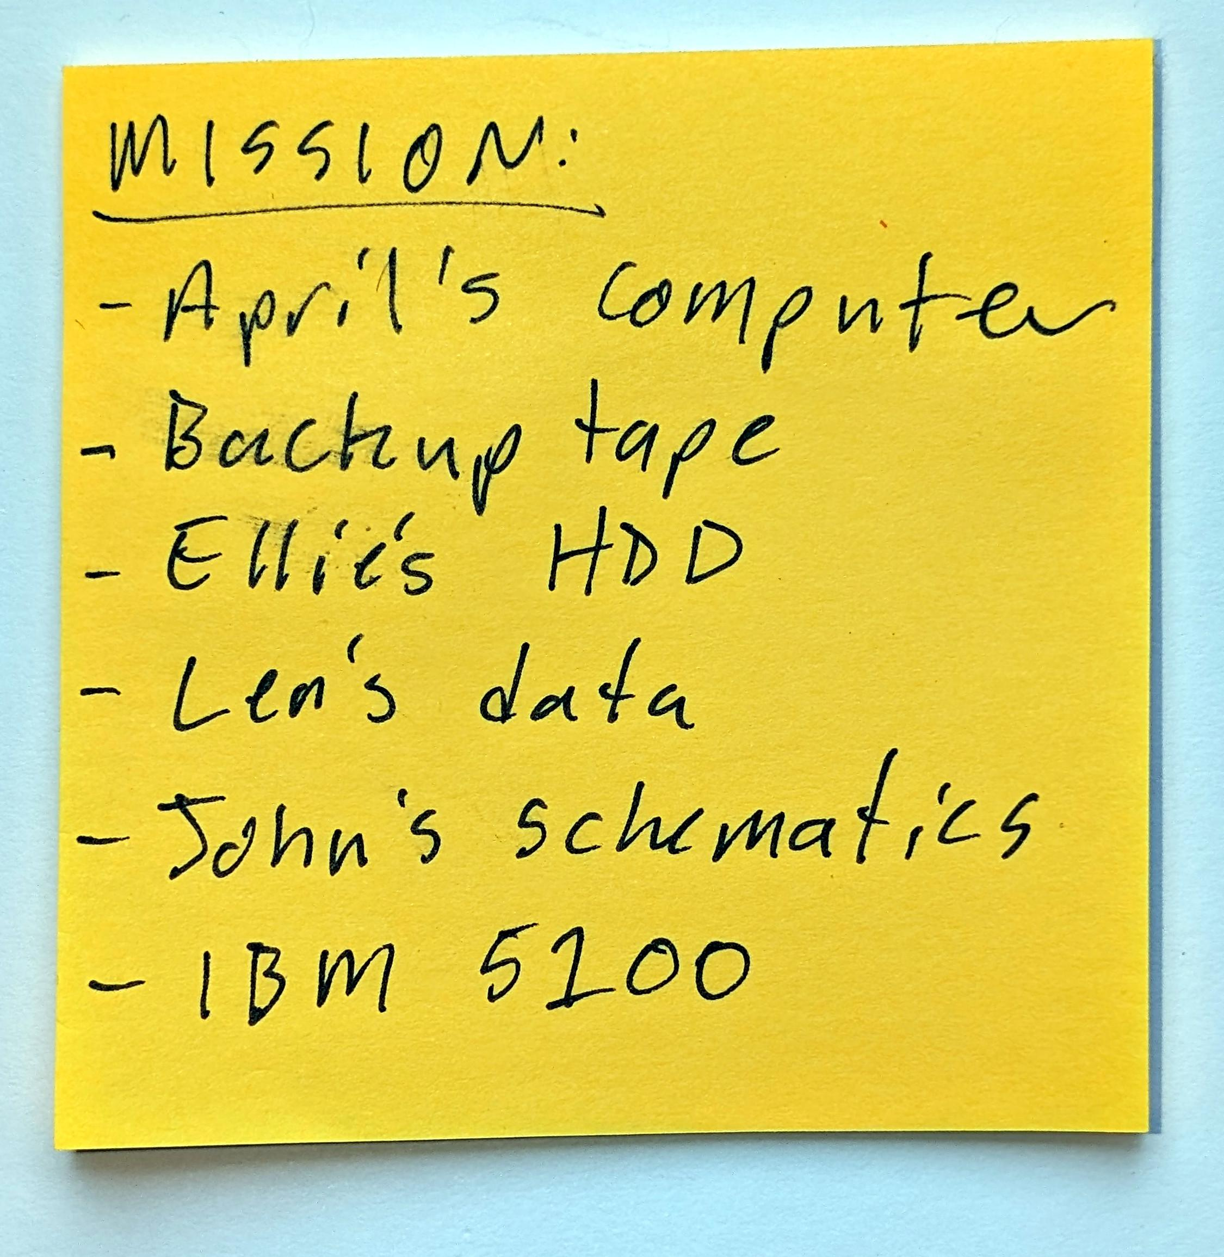
One Night in San Francisco
Your mission, should you choose to accept it.
In ONISF, you play the role of an unnamed thief who has been hired to steal a number of objects from a mysterious tech company’s office on the 13th floor of a San Francisco building. You start with after-hours access to the office and a checklist of items to steal. The game ends when you steal all the items and leave.

While the company has a number of physical and technological protections in place, you’ll need to defeat those controls using some classic tricks of the trade. You’ll start the game with a way into the office and a checklist that will show which items you have, and which ones you still need to find. Unfortunately, since you weren’t able to bring in any tools, you’ll need to figure out how to acquire the items using the objects you find in the office.

When you start the game, read all the information carefully and follow the instructions to complete the tutorial. Once you’ve found all the items, return to the elevator to leave!

Here’s a map of the office layout:
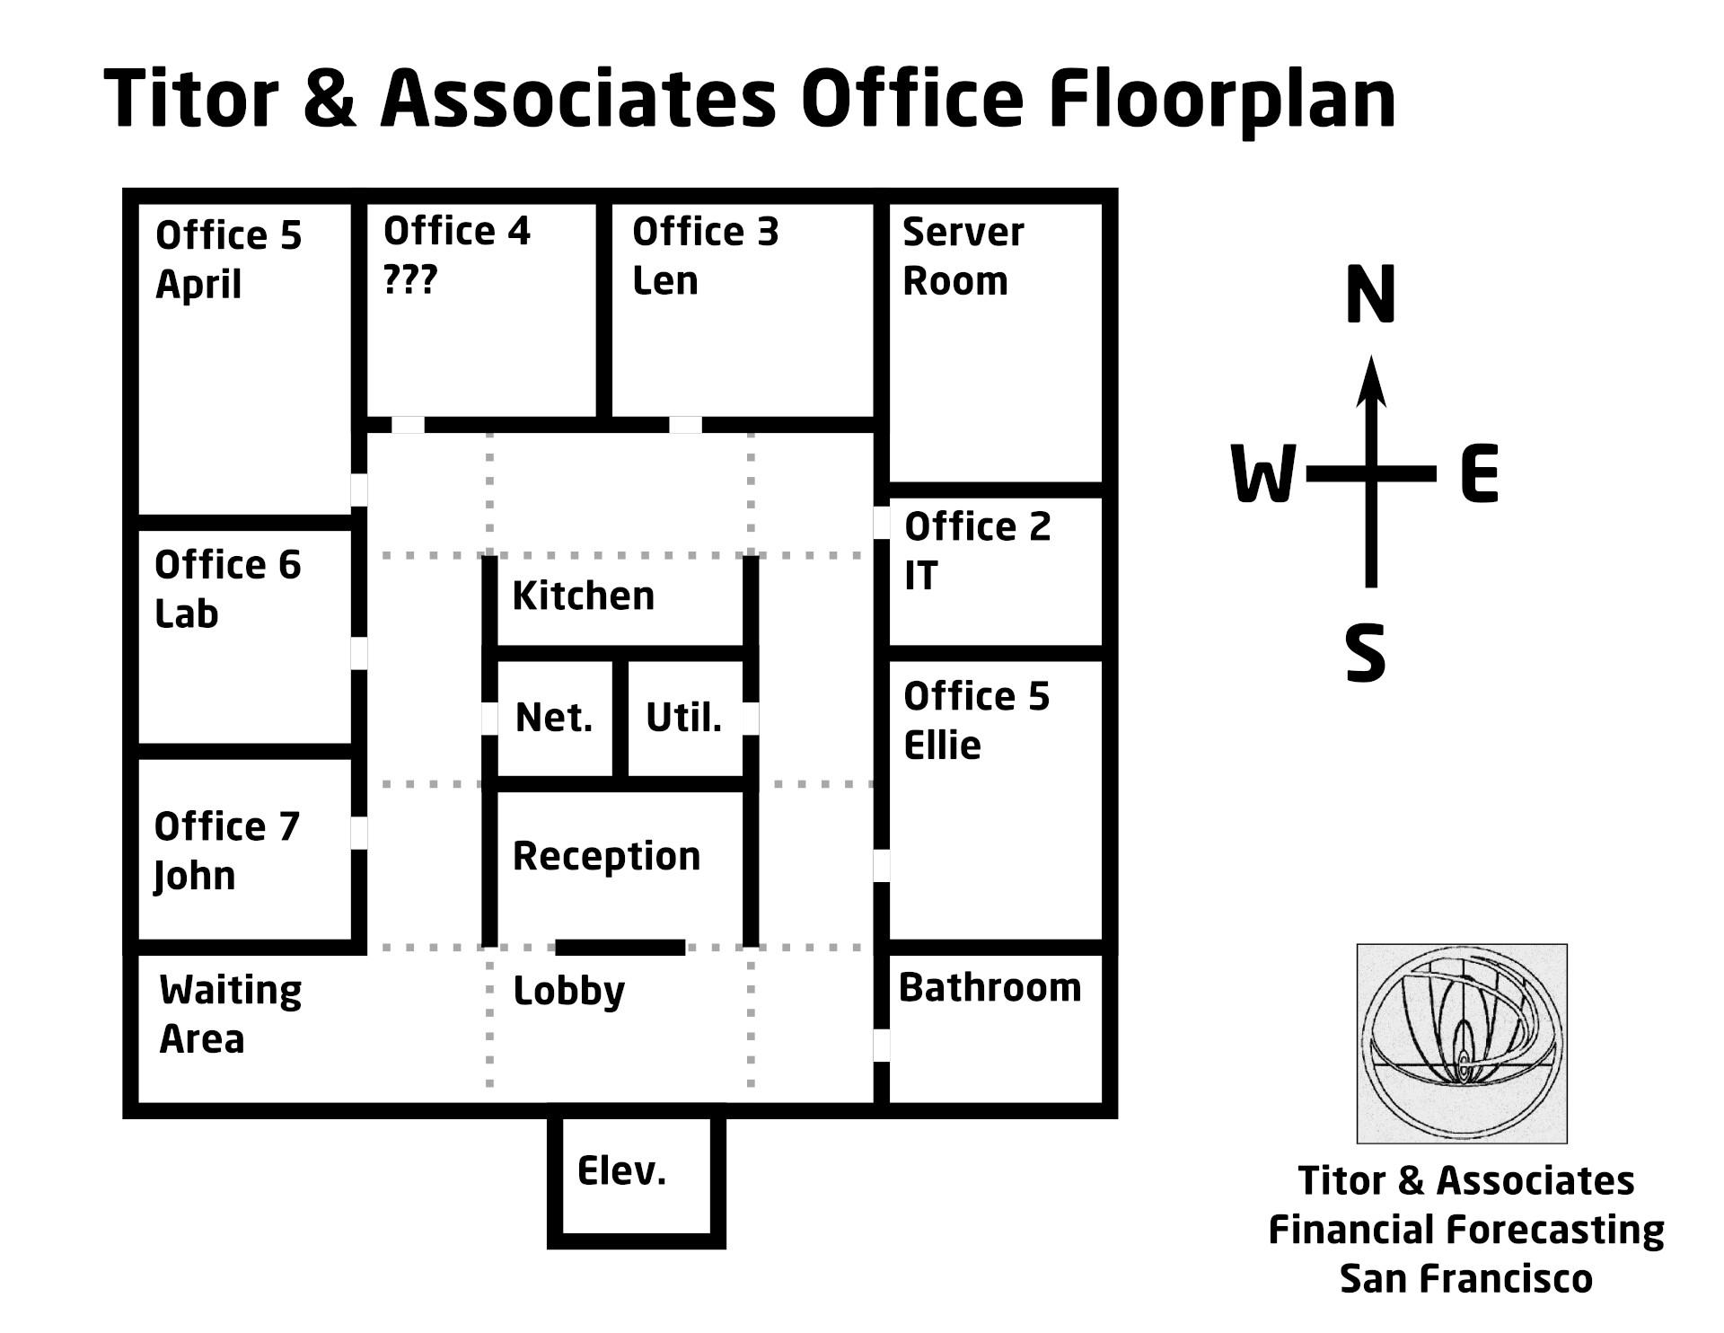
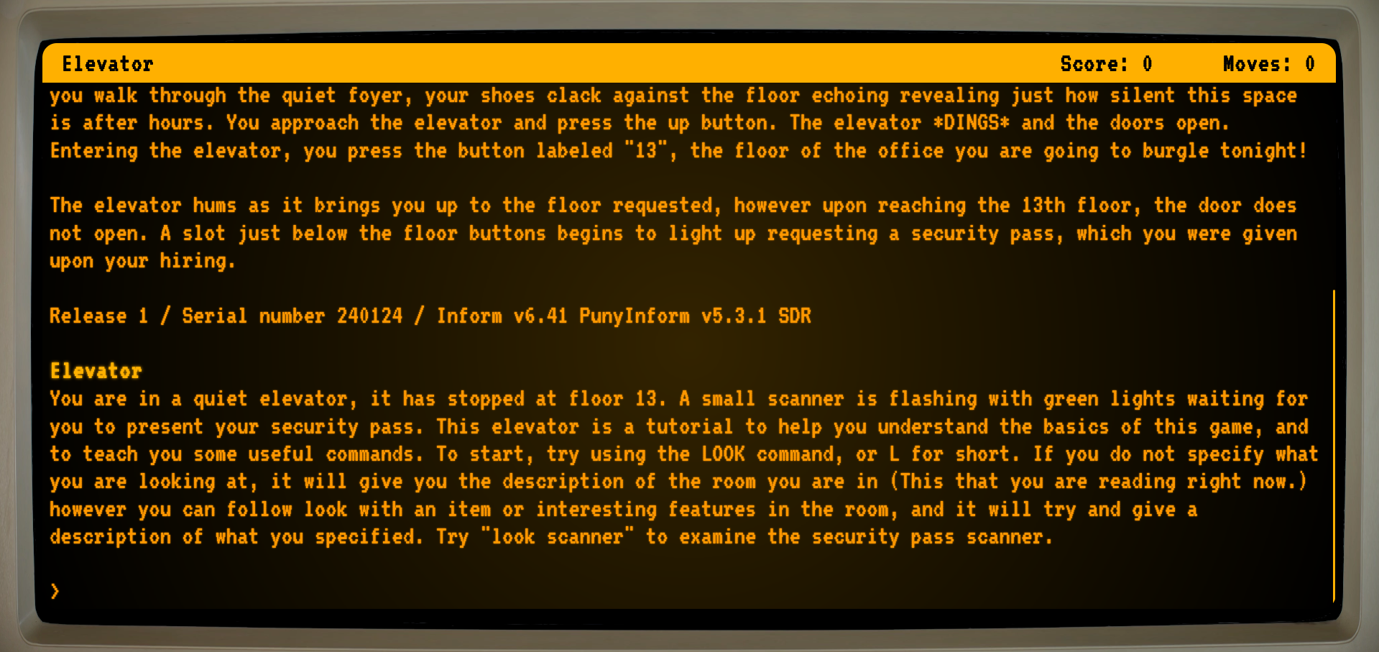

Playing the Game
ONISF is played online using a browser-based text adventure interpreter. You don’t need anything except this manual and the game.

Useful Verbs
Interactive fiction (IF) games typically support a large number of verbs – the “action words” that can be used in the game. Many of these are so frequently used that they are standard, like “look”, “go”, “open”, and so on. Other verbs are specific to (i.e., provided by) particular objects; for example, a toilet plunger might provide the “plunge” verb. Sometimes, part of the fun is figuring out what the right verbs are to accomplish a task, but other times it can feel like you’re trying out all the synonyms because the programmers only accepted one of them.

Since this might be your first IF game experience, and because it’s really an educational tool, we don’t want you to struggle to figure out what arcane incantations the game requires for you to succeed. So, while you can beat the game in many ways and with many words, here’s one list of verbs that you could use to complete the game:
climb
down / d
drop
east / e
hint
insert
inventory / i
jimmy
look / l
north / n
open
plunge
quit
remove
south / s
take / take all
throw
turn on
type
unlock
unscrew
up / u
west / w

Hints
One Night in San Francisco features the exciting new Hint-o-maticTM contextual hint system. If you’re in a room and need a hint, try typing “hint” – and the game might have a useful hint for you. But watch out, hints will cost you points. :)

Credits
Concept: Peter Peterson & April Seliger
Writing: April Seliger, Peter Peterson, & Nick Moffitt
Lead Programming: April Seliger
Grand Inform Wizard and Mage of the Parchment: Nick Moffitt
Other Programmers: Peter Peterson, Jet Li Braun

Written using PunyInform, a more efficient variant of Inform. We use Parchment to play Z-machine games in a web browser.

Thank you to our testers!

Images:
- IBM 5100 line drawing
https://archive.org/details/ibm_5100_ros
- John Titor insignia
http://www.johntitorfoundation.com/
- Toilet plunger
By Usama - Лично от меня, CC BY-SA 3.0, https://commons.wikimedia.org/w/index.php?curid=1607481
- Zork box art. By http://www.gue-network.com, Fair use, https://en.wikipedia.org/w/index.php?curid=1834793

